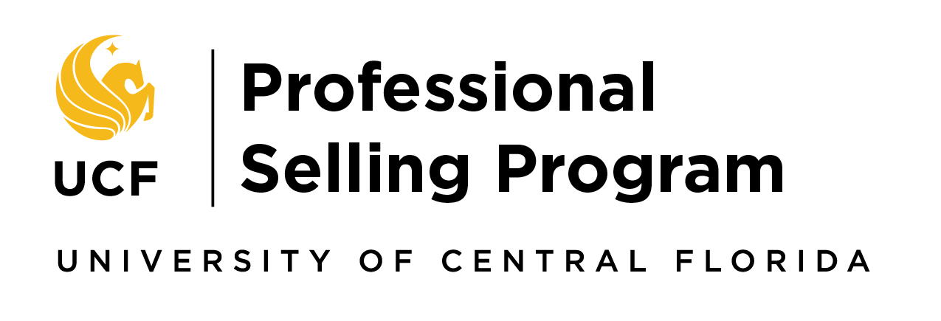
Program Application
Start August 2023 - End May 2024

Submission Instructions: Submit your application by email to Dr. Steiger at william.steiger@ucf.edu and be sure to send Dr. Steiger an email with your YouTube video link.

Priority Deadline = Friday, Feb. 17, 2023 @ 3 p.m. Final Deadline = Friday, March 31, 2023 @ 3 p.m.

- Contact Information:

Name PID

Street Address

City State Zip Code

Home Telephone ( ) Cellular Telephone ( )

E-mail

Declared Major(s) Minor(s/)

Academic Achievements / Contributions:

Academic Affiliations:

Organization | Member Since | # of Club-Related  Meetings You Attended | Leadership Position(s) Held  (if applicable)
Alpha Kappa Psi
Delta Epsilon Chi
Delta Sigma Pi
Honors College
The Sales Club
Society for Marketing
Professional Services (SMPS)
Other:

Overall GPA Major GPA Expected Graduation

Awards / Achievements:

Special Award / Honor Date Received

IIIa. Prerequisite Coursework:
Minimum grade of B in MAR 3023 is required to submit an application. A “B-minus” in MAR 3391 or 3407 is required for acceptance.
You can apply before completing MAR 3391 or 3407.

Marketing Courses Taken
Course | Semester Taken | Grade
MAR 3023 – Intro to Mktg
MAR 3391 – Prof. Selling or
MAR 3407 – IB Sales/Mktg

IIIb. PSP Minor Coursework:

Course  Number | Title | When Offered | Prerequisites
MAR 3611 | Mkt Analysis/Research Methods | Fall, Spring, Summer | MAR 3023
MAR4418 | Sales Force Management | Fall, Spring, Summer | MAR 3023
MAR 4415 (PSP) | Advanced Professional Selling | Fall & Spring | Admission to  Sales Program
MAR 4413 (PSP) | Strategic Issues in Sales | Fall & Spring | MAR 4415

Internship / Work Experience:

Employer Position Dates of Employment
_________________________________________________________________________________
_________________________________________________________________________________

Have you ever sold any actual product or service? If so, please tell us about that and include how you
achieved your best results.

Extra-Curricular Activities:
Detail below your involvement in community service projects, other volunteer work, sports, hobbies, membership in social organizations, etc.

Other:
Why are you interested in a career in sales?__________________________________________________
______________________________________________________________________________________

How did you hear about the program? Did a current PSP student or alum recommend you apply?
______________________________________________________________________________________
______________________________________________________________________________________

Application Requirements:
  - Resume
  - Degree Audit
  - Signed, completed application
  - YouTube Video: Maximum 3 minutes. Post to an “unlisted” channel (instructions are on the back of this page) and paste the link into an email to Mr. Steiger william.steiger@ucf.edu:
    - Your video should answer this question: What unique skills and experiences do you bring to the UCF Professional Selling Program that will make it a better program?
  - Short Answer – provide your answer to the questions below. Page limit – ½ page each.
    - You’re a student in the Professional Selling Program and have a part time job serving at a local restaurant. Your Advanced Professional Selling teacher e-mailed the class to see who would like to have dinner with Company X (one of our Corporate Partners) when their representatives are in town next week. You respond to the e-mail to reserve a spot, later realizing you have a work shift at the same time, creating a scheduling conflict. How do you handle the situation?
    - How do you currently manage your time? (please be specific) How do you see that changing if you are offered a seat in the Professional Selling Program?
    - Describe a time when you did more than was expected in one of your classes.
    - Tell us about your biggest accomplishment and how you went about accomplishing it.
  - Any other materials you wish to be considered as part of your application (i.e. letters of recommendation, career portfolio, samples of academic work, work-related accomplishments)
  - G. Before final selections, select candidates will complete three interviews.

Program Eligibility
- Admission by Marketing Department approval: eligibility is determined by UCF catalogue year.
  - All UCF majors are eligible to apply. Marketing majors will earn a major in Professional Selling. All other majors will earn a minor in Professional Selling

Signature
I have reviewed and understand the program requirements.

Signature Today’s Date

Uploading your YouTube Video

- Open YouTube and find the Upload button on the top, right corner of the screen.
- In the next window you will see “Select Files to Upload”. Under this designation there is a drop-down box. Click on the arrow and click “Unlisted”, not public or private.
- Click on the large arrow and find your video (wherever it is saved).
- Click on upload
- It can take 15 minutes to upload fully so don’t close the window while it’s uploading
- When it’s 100% uploaded, your video will have a URL on the left side of the screen.
- Send an email to Mr. Steiger william.steiger@ucf.edu with the YouTube video URL.

